NERS: A Neonatal Emergency Response Swaddle for Newborn Resuscitation in Low-Resource Kenyan Health Facilities

Cedric J. Murage Mwangi • Hilda Kalino • Keturah Kirabo
cedricmurage10@gmail.com . hildakalino@gmail.com . keturahkirabo@gmail.com

1. Project Description & Relevance to Healthcare
Birth asphyxia is the leading cause of neonatal mortality in Kenya, accounting for 31.6% of all newborn deaths, with approximately 31,000 neonatal deaths recorded in 2024 at a rate of 20.7 per 1,000 live births [1], [2]. The Golden Minute, the first sixty seconds after birth, is the highest critical window for newborn resuscitation. Every 30-second delay in initiating ventilation raises the mortality risk by 16% [3]. In low-resource Kenyan facilities, a single birth attendant is usually tasked to manage thermal regulation, airway clearance, and chest stimulation, using separate non-integrated pieces of equipment, under acute time pressure. This fragmentation, directly observed by the team during a clinical immersion at Thika level 5 hospital, leads to delays during the golden minute, that can cost a life.
The Neonatal Emergency Response Swaddle (NERS) is a single integrated device that delivers all three resuscitation functions simultaneously the moment a non-breathing newborn is wrapped in it. The swaddle integrates an embedded heating strip with an MLX90614ESF non-contact infrared sensor for real-time thermal monitoring; a 28BYJ-48 stepper motor in a peristaltic-pump configuration for controlled airway suction; and two counter-rotating 28BYJ-48 motors with padded compression elements for rhythmic bilateral chest stimulation. An Arduino Nano V3.0 coordinates all three modes, each independently activated by a labelled push button and displayed in real time on a 0.96-inch SSD1306 OLED. By eliminating the device-to-device transition time inherent in current practice, NERS directly targets the root, time-critical cause of preventable neonatal death in exactly the setting it was designed in and tested for.
2. Innovation & Originality
No existing device, commercial or research-stage, combines thermal regulation, airway clearance, and chest stimulation in a single wearable form factor at this cost. The BabySaver platform (Uganda, 2025) improved resuscitation outcomes but does not integrate automated suction or compression and requires importation [7]. Standard Kenyan facility equipment (resuscitaire, wall suction, manual two-finger compression) remains entirely fragmented. NERS differentiates itself on four dimensions:
- Three-in-one swaddle integration: all sensors and actuators are pre-positioned on the neonate's body the instant the swaddle is applied, eliminating manual placement and device-switching steps entirely.
- Independent, concurrent modal activation: any combination of warming, suction, and compression can run simultaneously, validated under integrated testing, matching real resuscitation demands.
- Counter-rotating bilateral compression: two stepper motors replicate the preferred two-thumb encircling technique mechanically, removing operator-dependent variability [5].
3. Technical Feasibility
A first working prototype has already been built and tested. All three subsystems were validated independently and concurrently on a neonatal mannequin. The MLX90614ESF reported accurate temperatures when tested in room temperature and warm surfaces like a cup of hot water. The peristaltic suction motor generated a confirmed travelling compression wave through silicone tubing, and the dual massage motors produced coordinated, rhythmic bilateral chest compression without interference between subsystems. The shared I2C bus (sensor at 0x5A, OLED at 0x3C) operated without address conflict throughout testing.
Funds requested under this grant will go directly toward the next stage of replacing the current Veroboard electronics with a custom PCB, integrating a calibrated load-cell/pressure-film verification of compression depth and suction pressure, and procuring medical-grade silicone for the compression pads and skin-contact warming surface in place of the prototype's PLA and fabric. This is the minimum viable next step between the current proof-of-concept and a usability study with real birth attendants, and further funding will be sought for the subsequent clinical-validation phase.
4. Impact & Community Engagement
NERS targets low resource public health facilities, which serve the majority of Kenyan births where skilled, multi-person resuscitation teams are unavailable. If integration removes even approximately 60 seconds of device-switching delay observed at Thika Level 5 Hospital, the literature implies an approximately 32% relative reduction in mortality risk attributable to that delay alone [3]. The thermal subsystem additionally targets the 17.5% of Kenyan neonatal admissions found to arrive hypothermic, a state associated with a 35% increase in odds of death [4].
Community engagement will continue through the same Invention Education Programme pathway that supported prototype development. Device test data will be shared with Thika Level 5 Hospital and other partner facilities, and findings will be submitted for presentation at Kenyatta University's CDIE lab.
5. Team Capability & Collaboration
Team Member & Role | Institution | Contribution
Cedric J. Murage Mwangi — Hardware & Firmware Lead | Kenyatta University | Circuit design, firmware, actuator/sensor integration, mechanical design, prototype assembly and testing
Hilda Kalino — Systems & Sustainability Lead | Malawi University of Science and Technology, Biomedical Engineering | Budget planning, literature review, implementation and sustainability planning, stakeholder engagement
Keturah Kirabo — Clinical & Validation Lead | Mbarara University of Science and Technology, Biomedical Engineering | Clinical immersion analysis, performance documentation

We are a three-person team from Kenyatta University, Malawi University of Science and Technology and Mbarara Hospital, brought together through the Medical Device Innovation Summer Program hosted at Kenyatta University's Centre for Design, Innovation & Engineering lab.
6. Implementation Plan & Milestones
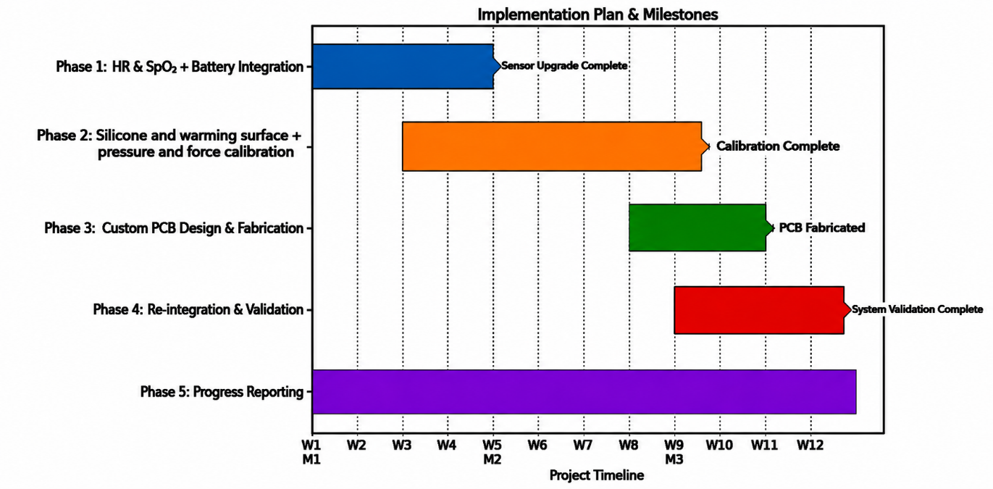
7. Sustainability
NERS's sustainability rests on four factors:
- Affordability: keeps the device within reach of low resource facilities procurement budgets without external subsidy.
- Impact on Mortality: The device addresses factors that contribute to neonatal deaths in Kenya.
- The design aligns directly with Kenya's Newborn and Child Health Strategic Plan 2022–2026, which explicitly prioritizes affordable, deployable neonatal innovations [5].
- Personnel Efficiency: reduced procedural burden on understaffed facilities creates a durable operational incentive for continued adoption beyond the grant period.
This project has received no prior external funding; the prototype to date was funded by the CDIE management. The Catalyst Grant is the first external funding sought, and it is intended as a stage gate, not the final step. Should pilot results from the funded calibration phase be strong, the team intends to pursue follow-on funding from the KEMRI Innovation Fund and other organizations to support full clinical validation and the Kenya Pharmacy and Poisons Board regulatory approval.
8. Budget Justification
The table below itemizes the requested USD 1,000, allocated to moving the validated proof-of-concept to a calibrated, PCB-integrated device.
No. | Item | Qty | Cost (USD) | Justification
1 | Custom PCB design & fabrication (x3 prototype boards) | 3 | 260 | Replaces Veroboard assembly; reduces footprint and improves reliability for usability testing
2 | Load cell + pressure-film calibration kit | 1 | 180 | Required to verify compression depth and suction pressure
3 | Medical-grade silicone (compression pads & warming surface) | 3 sets | 190 | Replaces prototype PLA/fabric for skin-contact biocompatibility ahead of human usability testing
4 | Sensors, motors & drivers (replacement/spare set for 3 prototypes) | 1 set | 150 | Better accurate sensors and actuators, and also increasing sensors for feedback and safety.
5 | Ethics submission & documentation costs | — | 120 | Administrative and printing costs for usability-study ethics protocol submission
6 | Miscellaneous | — | 100 | General consumables
 | TOTAL |  | 1,000
References
[1] UNICEF. Kenya Maternal and Newborn Health Disparities. UNICEF, New York, USA.
[2] UN Inter-Agency Group for Child Mortality Estimation. “Levels and Trends in Child Mortality Report 2025.” UNICEF, WHO, World Bank, UN DESA, 2025.
[3] B. Mwangi et al., “Practice and outcomes of neonatal resuscitation for newborns with birth asphyxia at Kakamega County General Hospital, Kenya,” BMC Pediatrics, vol. 18, no. 1, p. 166, 2018.
[4] J. Wainaina et al., “Hypothermia amongst neonatal admissions in Kenya,” Frontiers in Pediatrics, vol. 12, p. 1272104, 2024.
[5] Ministry of Health, Republic of Kenya. “Newborn and Child Health Strategic Plan 2022–2026.” Nairobi: MOH Kenya, 2022.
[6] ILCOR NLS Task Force. “2023 ILCOR Scoping Review — Comparison of techniques for providing cardiac compressions in neonates.” ILCOR Continuous Evidence Evaluation, 2023.
[7] M. W. Musaba et al., “Feasibility and acceptability of using the BabySaver resuscitation platform and NeoBeat together for neonatal resuscitation in a low-resource setting,” PLOS ONE, 2025.

